Acid-Base Extractions

**Reference:** Handout; Chemistry Lessons: acid-base reactions, use of separatory funnel, liquid-liquid extraction, use of a rotary evaporator; Zubrick, CH. 10, 15-16, and 37; “Extraction” Movie

**Purpose:** To use liquid-liquid extraction in separating different mixtures (acid, base, and neutral compounds)

**Table of Reagents:**

|  |  |  |  |  |  |  |
| --- | --- | --- | --- | --- | --- | --- |
| **Reagents** | **Amount** | **MW** | **Mmol** | **BP (°C)** | **MP (°C)** | **Density** |
| Benzoic Acid | ~300 mg  mixture | 122.12 g | 20.49 | 249.2°C | 123 °C | 1.27 g/cm3 |
| Benzil | 210.23 g |  | 347°C | 95 °C | 1.23 g/cm3 |
| Meta- Nitroaniline | 138.14 g |  | 306 °C | 114 °C |  |
| Diethyl Ether | ~10 mL | 74.12 g |  | 34.6 °C | -116.3 °C | 0.713 g/cm3 |
| HCl (aq) | ~4 mL | 36.46 g |  | -85.1 °C | -114.2 °C | 1.19 g/cm3 |
| NaOH (aq) | ~4 mL | 39.997 g |  | 1388 °C | 318 °C | 2.23 g/cm3 |
| NaCl(aq) | ~4 mL | 58.44 g |  | 1465 °C | 801 °C | 2.16 g/cm3 |
| Na2SO4 | ~1 g | 142.04 g |  | 1429 °C | 884°C | 2.66 g/cm3 |
| Water (H2O) | Varied | 18.02 g |  | 100 °C | 0 °C | 0.997 gm/cm3 |

**Safety:** Neutralize the strong acids and bases with water. Vent the funnel away from anyone(including yourself). Benzoic Acid, Benzil, meta-nitroaniline, and Diethyl ether are irritants. Always wear gloves and goggles.

|  |  |
| --- | --- |
| **Experimental Procedures** | **Data & Observations** |
| **1.** Unknown mixture of benzoic acid, benzil, and meta-nitroaniline will be given. Weigh out ~300 mg of the unknown mixture and dissolve with 10 mL of diethyl ester. Pour in small separatory funnel. ***Use smallest size glassware*** | *Mixture:* 304.6 mg  *Observations:* Solution turned yellow and stained the glass |
| **2.** Add 4 mL of 3 M HCl. Shake and allow to separate. Drain into a small Erlenmeyer Flask by opening the stopcock (removes the bottom HCl layer). Repeat again with 4 mL of 3M HCl. Combine with the other aqueous layer. Set aside and label flask “HCl Layer”. | *Observations:*   * Solution began to separate. Yellow layer on top. White precipitate in the middle layer. Rosy-Pink layer at the bottom (HCl). * White layer disappeared upon addition of 4 mL of HCl |
| **3.** Same Process with Step 2. However, use 4 mL of 3 M NaOH. Label flask “NaOH Layer” and set aside. | *Observations:*   * Layers began to form: Yellow (top layer) and clear (bottom layer) * NaOH color (bottom layer): yellow light with clear mix |
| **4.** Add 2 mL water in separatory funnel with the ether layer. SHAKE and allow to separate! Afterwards, remove the bottom H2O layer. Repeat with another 2 mL of water. Next, use 2 mL of Brine (Na2SO4). Discard aqueous layer and pour ether layer into Erlenmeyer flask. Label the flask “Ether Layer”. | *Observations:* Pressured fumes began to release at the top when preparing to remove water |
| **5.** Grab flask labeled “HCl Layer”. Add 6 M NaOH until the solution turns basic (red litmus paper will turn blue). Products will start to form when you add the base 🡪 add until solid stays. Make an ice bath and let the solution cool in it. Use vacuum filtration to get solid and rinse with 2 mL of cold water. Put in your cabinet to air dry! | *Observations:* Slowly turned yellow as we dropped the NaOH into the flask. Formed yellow solids at the end! |
| **6.** Grab flask labeled “NaOH Layer”. Add 6 M HCl until the solution turns acidic (blue litmus paper will turn red). Repeat the process as described in Step 5.  ***For steps 5 & 6, slowly drop the NaOH or HCl*** | *Observations:* Slowly formed white solids near the bottom during the process |
| **7.** Grab the flask labeled “Ether Layer”. Add ~0.5-1.0 g of Na2SO4 to the flask. Na2SO4 will soak up the water! Add Na2SO4 until the solid is able to move freely! Mix flask and add stopper to the top. Set aside in cabinet until next lab. | *Observations:* The Na2SO4 stuck to the bottom of the glass, but slowly was able to move around the glass. |
| **8.** Gravity filter ether solution into a small flask. Rinse out flask with 1-2 mL of ether. Evaporate with stream of air. Solvent should remain after solid has evaporated. |  |
| **9.** Weigh out all three solids and measure the melting point!  % recovery = $\frac{Mass Isolated}{Original Mass of Mixture}×100$ | *Meta-Nitroaniline Recovered:* 51.7 mg  *Benzoic Acid Recovered:* 73.4 mg  *Benzil Recovered:* 68.3 mg $$\frac{51.7}{304.6}×100=16.9\% Meta-Nitroaniline$$ $$\frac{73.4}{304.6}×100=24.1\% Benzoic Acid$$ $$\frac{68.3}{304.6}×100=22.4\% Benzil$$ |

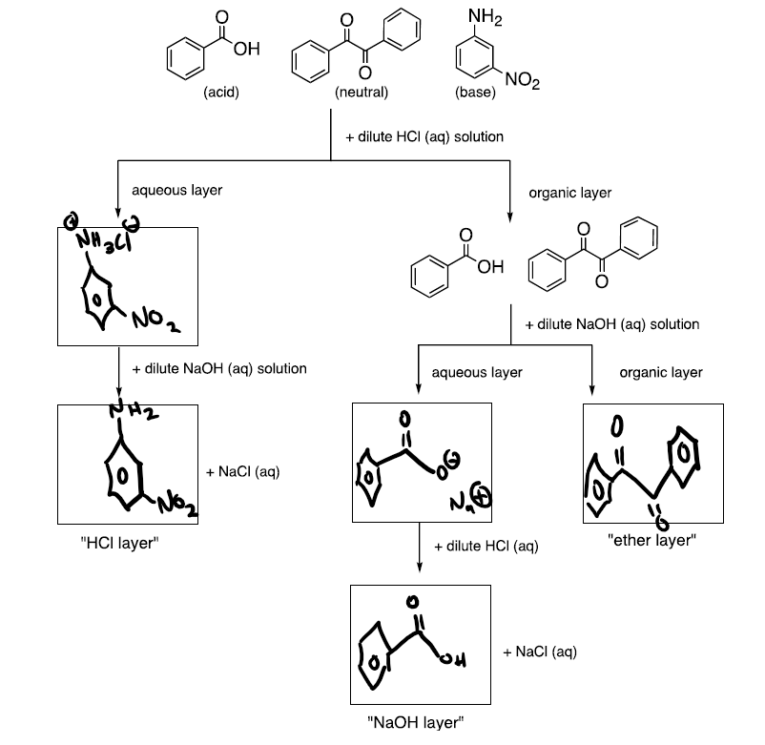

**Post-lab Questions:**

**1. a.**

|  |  |  |  |  |
| --- | --- | --- | --- | --- |
| **Compounds** | **Mass (mg)** | **Melting Point Range (°C)** | **Melted (°C)** | **% Recovery** |
| Benzoic Acid | 73.4 mg | 121 °C – 123 °C | 123.1 °C | 24.1 % |
| Benzil | 68.3 mg | 94 °C – 96 °C | 95 °C | 22.4% |
| Meta- Nitroaniline | 51.7 mg | 114 °C | 113.3 °C | 16.9% |

**b.** Overall our experiment in separating the different compounds was a success! We did not experience any melting point depreciation in any of the compounds, which tells us that our compounds are the pure results of each solid! However, our result was not a 100 % recovery of all the cumulative compounds, which was probably due to loss during filtration as well as we spilled some of our compounds in our ice bath during the process.

**2. a.** Water will be at the bottom due to water (0.997 gm/cm3) being denser compared to diethyl ether (0.713 gm/cm3).

**b.** In a case where I did not know the density of a solvent and I was trying to figure out if it was organic or not, I would result in performing this simple test. I would see if the solvent would dissolve in water, since most organic molecules are non-polar which means they would not dissolve in polar solvents like water. If the solvent dissolves in with the water then it’s not an organic molecule, otherwise, you would see two layers form (top and bottom), which in most cases the organic molecule will be lighter than the water, so it would be on the top.

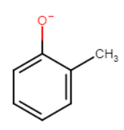**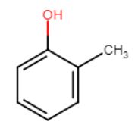3.** The most acidic proton in In-OH is the one circled at the bottom, because that hydrogen is connected to an oxygen, which is highly electronegative. As a result, once the H+ is removed, the conjugate base is very stable due to resonance within the structure.

-H+

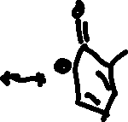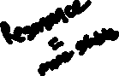

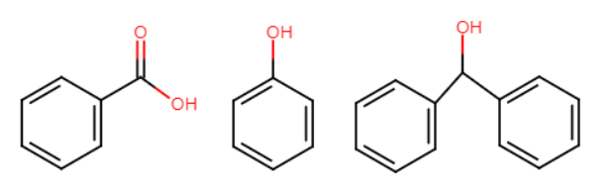**4.**

B.

P.

D.

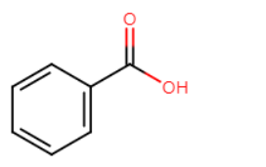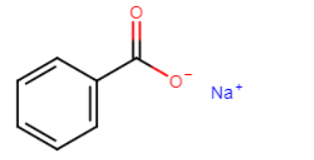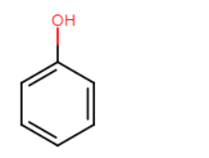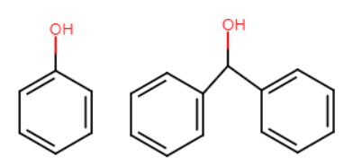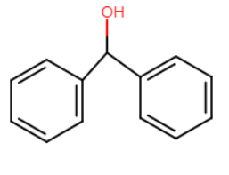

**+ NaCl**

**+ HCl**

**Aqueous Layer**

**+ H2CO3**

**Organic Layer**

**+ NaCl**

**+ HCl**

**Aqueous Layer**

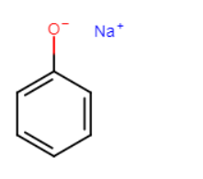

**+ H2O**

**Organic Layer**

**+ NaOH**

**+ NaHCO3**

**5. Two 150 μL portions of Ether**

*150 – 51.64 = 98.36 mg left*

$K_{p}=3.5=\frac{x}{150-x}×\frac{1000}{150}$ $K_{p}=3.5=\frac{x}{98.36-x}×\frac{1000}{150}$

$0.525=\frac{x}{150-x}$ $0.525=\frac{x}{98.36-x}$

$78.75=1.525x$ $51.64=1.525x$

**x = 51.64 mg A (1st portion) x = 33.86 mg A (2nd portion)**

**Total Extraction of A**

**51.64 + 33.86 = 85.5 mg of compound A**